The Origins of TBR
The Bönninghausen Repertory – therapeutic pocket book method
The Bönninghausen Repertory – therapeutic pocket book method (TBR), was first published by Hahnemann Institute Sydney in 2000, after five years spent carefully revising and retranslating, entry by entry, the original German Therapeutisches Taschenbuch.
In 2010, TBR 2nd edition was released, following a total of fifteen years of fine tuning and perfecting this work; the result being the repertorial work which most accurately represents the fundamental principles established by our founder, Dr Samuel Hahnemann.
Soon after his induction of the general principle of similars in medicine in 1810 (marking the birth of Homœopathy), Hahnemann soon realised the growing volume of known drug effects (materia medica), required an index for easier access. Several attempts were made to compile references to the collected works on materia medica. These however, were nothing like a repertory as we know it today but rather long lists of single symptoms each with a single remedy attached, and proved to be too clumsy and bulky to be of any practical use.
Bönninghausen, from early in his study of Homœopathy, also recognised the need for an accurate referencing tool. His prior training in law and botany gave him the necessary skills to take on this task:
“… which fact caused me, even at the beginning of my study of this excellent and invaluable treatment, to think of expedients which would make the choice of suitable remedies easier and more certain, by this means bringing the symptoms of each one more clearly into view;”

His first printed attempt, The Systematic Alphabetic Repertory of Antipsoric Remedies (SRA) was published in 1832, and was followed in 1835 by a repertory for the non-antipsorics (SRN). For the first time, consistent elements of a symptom were identified and converted into rubric heading format, arranged systematically and alphabetically, with also the introduction of a grading system. These two works form a single reportorial model which we refer to collectively as The First Repertory (TFR).
Bönninghausen however was still dissatisfied with the evergrowing and cumbersome structure of his repertory, and focused on developing a ‘new and improved method,’ which received Hahnemann’s full approval, and revolutionised the approach to selecting the similimum.
“The result proved favourable beyond expectation and our late master having pronounced my idea to be an excellent and eventful one, I did not hesitate any longer to finish the work, which i now present to the homœopathic public…”

Bönninghausen’s, Therapeutisches Taschenbuch was first published in 1846, simultaneously in German, French and English.
It is important to understand that the basic structure of TFR, a structure which Bönninghausen discarded due to its cumbersome inadequacy, became incorporated into Kent’s Repertory and thereby into the majority of the repertories still in use today. Over the years, this has become further diluted by many republication errors and by the addition of much unsubstansiated material.

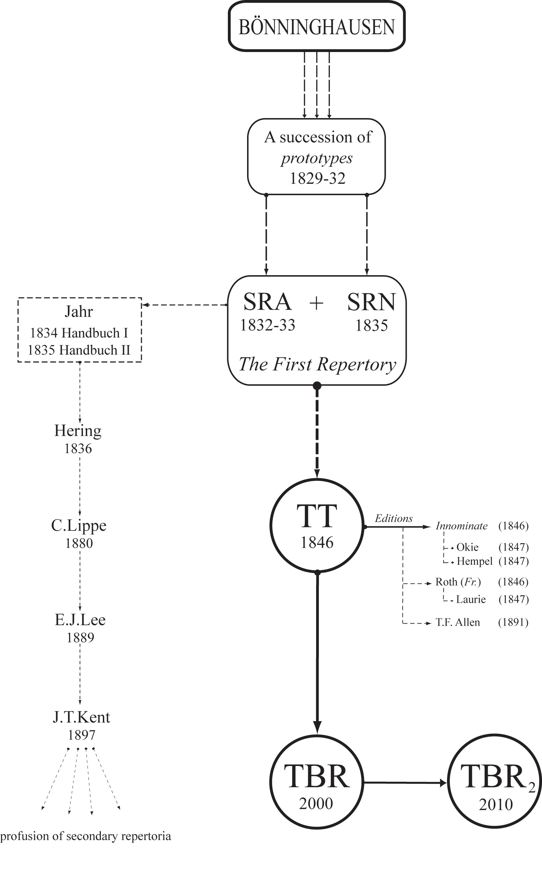

Diagram outlining the basic lineage of repertory initiated by Bönninghausen.
Early on in practice we here at the Hahnemann Institute Sydney became dissatisfied with the inadequacies of available reference works and therefore decided to undertake the mammoth task of retranslating and revising this valuable work of Bönninghausen. This subsequently lead to the birth of The Bönninghausen Repertory – therapeutic pocket book method.
Since its publication we have received nothing but positive attestations from practitioners and students around the world, rewarded daily by improvement in their clinical success rate.

SRA Preface (1st ed., 1832), in Boger, C.M. (Tr.): A Systematic Alphabetic Repertory of Homœopathic Remedies, 1899, first Indian edition, B.Jain, 1979, P.12
TT Foreword, in TPi, p.viii
Dimitriadis, TBR2 prologue, Sydney 2010

